**FLOUR**

**HERO**

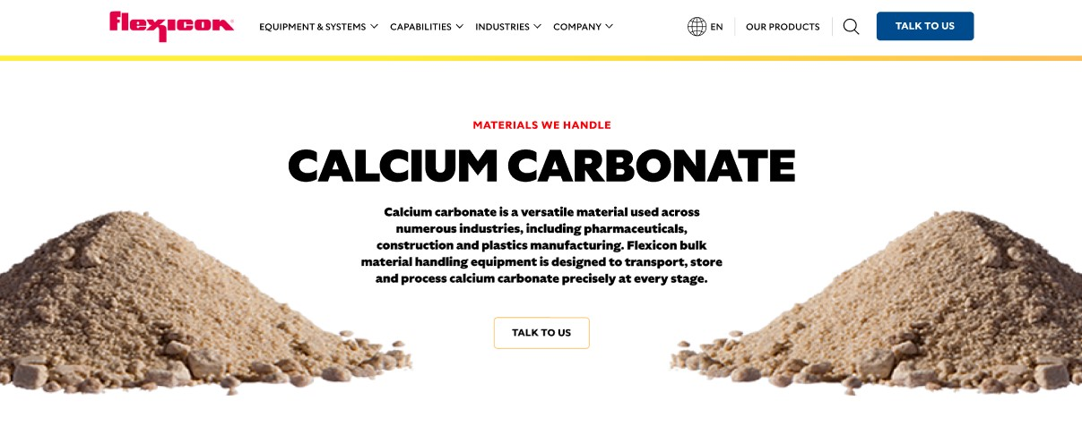

Flour is a fine, powdery substance produced by grinding, milling, or pulverizing grains, seeds, and roots. It is most commonly made from wheat and is the main ingredient in bread, a staple food in many cultures. Flexicon bulk material handling equipment is engineered to move, store, and handle flour safely and efficiently.

**Button**: Talk To Us

**SHELF #1 - PRODUCT DESCRIPTION**

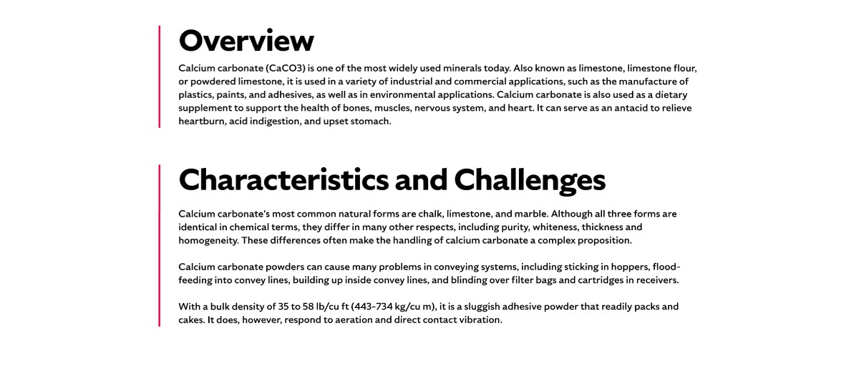

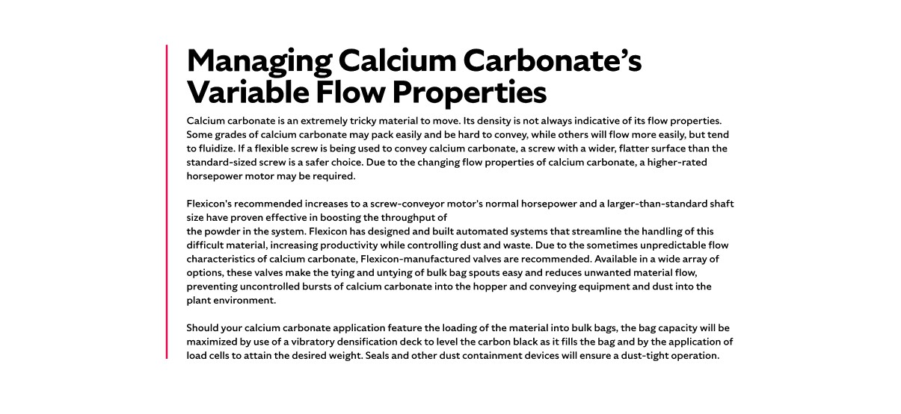

* **Overview**Flour commonly refers to wheat flour but can be made from many grains and roots such as rye, oats, rice, corn, taro root, and cassava, primarily for baking. The milling process separates the starchy endosperm from the grain kernel, reducing it to a fine powder suitable for various culinary uses. Flour’s versatility extends across many food products and baking applications.
* **Characteristics and Challenges**Wheat grains are primarily made up of the starchy endosperm, which accounts for about 85% of the kernel, while the outer bran layer and nutrient-rich wheat germ make up the remainder. During the milling process, the endosperm is carefully separated and ground into fine, powdery flour particles. Flour typically flows freely but is highly aeratable, meaning it can become suspended in air easily and may flood or overwhelm conveying systems if not managed properly. These characteristics require specialized handling to ensure smooth, controlled material flow and to prevent disruptions in processing.
* Flour dust is classified as a combustible dust by OSHA, posing a significant risk of explosions if proper precautions are not taken. When flour particles become airborne in sufficient concentrations and encounter an ignition source, they can create hazardous conditions leading to potentially devastating dust explosions. Therefore, effective dust suppression and collection systems are essential to minimize airborne particles and maintain a safe environment. Additionally, a thorough understanding of flour’s unique flow properties is crucial to designing handling systems that prevent dust buildup and ensure smooth, reliable operation. Proper engineering and safety measures help protect both personnel and equipment while maximizing process efficiency.

**SHELF #2 - FLEXICON SOLUTIONS**

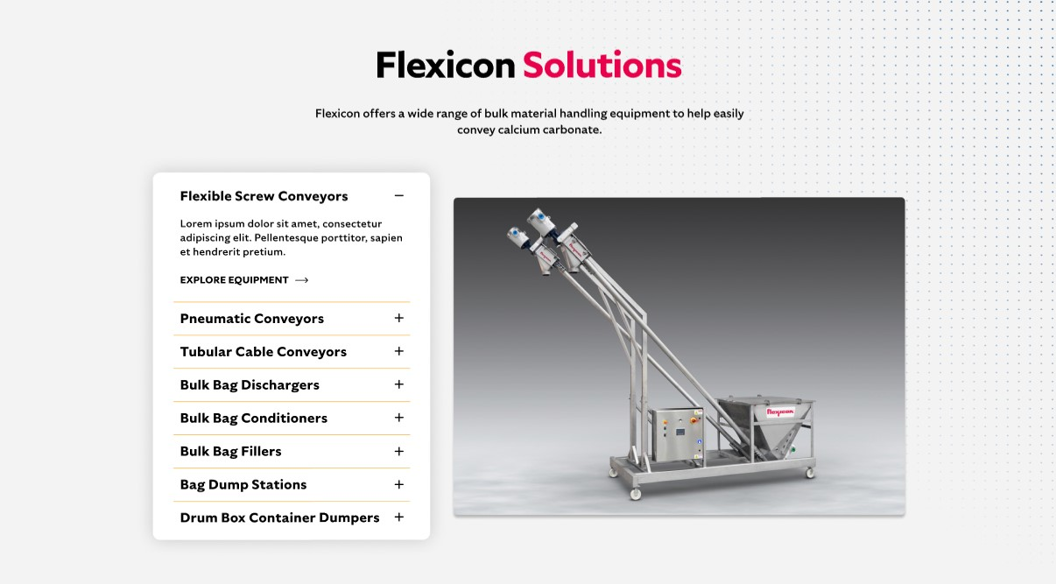

**Flexicon Solutions**

Flexicon offers a wide range of bulk material handling equipment to help easily convey calcium carbonate.

* **Flexible Screw Conveyor**: Smoothly convey flour while minimizing aeration and product degradation.
* **Pneumatic Conveyors**: Transport flour efficiently with controlled air flow to reduce dust and maintain steady material movement.
* **Tubular Cable Conveyors**: Enclose flour transport to prevent dust escape and protect product integrity.
* **Bulk Bag Dischargers**: Discharge flour from bulk bags completely using spring-loaded frames and bag activators to promote flow.sfsadfd
* **Bulk Bag Conditioners**: Loosen compacted flour within bulk bags to prevent bridging and ensure consistent discharge.
* **Bulk Bag Fillers**: Fill bulk bags with precision using densification decks and load cells for optimized capacity and weight control.
* **Bag Dump Stations**: Support manual unloading of smaller flour bags with dust containment features for a clean work environment.
* **Drum Box Container Dumpers**: Handle various containers ergonomically while minimizing dust and facilitating easy transfer.

**SHELF #3: LIFETIME PERFORMANCE GUARANTEE**

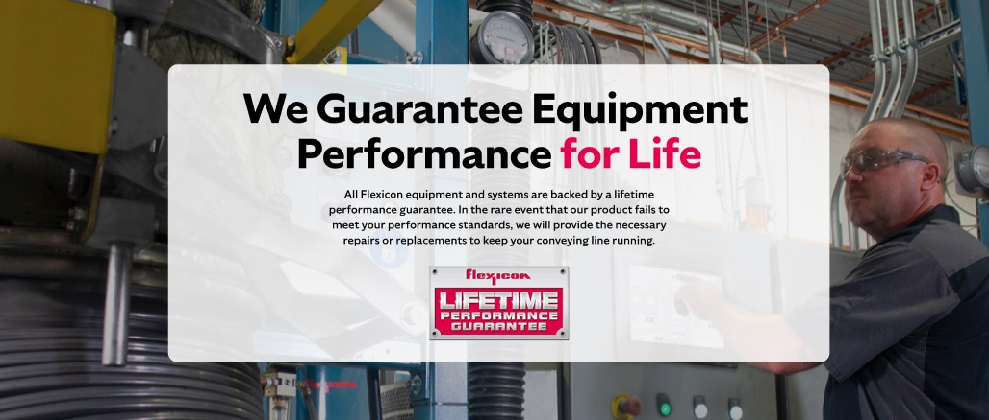

**Lifetime Performance Guarantee**

All Flexicon equipment and systems are backed by a lifetime performance guarantee. In the rare event that our product fails to meet your performance standards, we will provide the necessary repairs or replacements to keep your conveying line running.

**SHELF #4: CASE STUDIES**



**Overview**:

* Flour is the term used for the powdery substance resulting from the grinding, milling or pulverizing of grains, seeds, roots or other edible materials
* Wheat, rye, oats, rice, corn, taro root, and cassava are some examples of grains and roots that are ground into flour, primarily for baking
* Flour is the main ingredient in bread, which is a staple food in most cultures.
* In common usage, flour refers to wheat flour.

**Characteristics**:

* Wheat grains are composed of a starchy inner portion, called the endosperm, which makes up 85% of the grain kernel; the outer layers, known as bran, and the oily wheat germ comprise the remainder. The milling process separates out the endosperm and reduces it to fine particles.

**Challenges**:

* soy flour, oat flour, potato flour, rice flour, rye flour and wheat flour are all classified as "combustible dusts" by the United States Occupational Safety and Health Administration and the handling of these flours is subject to standards used by this agency to mitigate the risks of dust explosions. There is an average of ten wheat grain mill explosions in the United States per year,2 some with devastating consequences. These explosions are usually caused by the presence of a "fire triangle," that includes oxygen, an ignition source and a fuel, such as flour dust.
* Because of the potentially explosive nature of flour dust, suppression and collection are of vital importance when transporting flour.
* understanding of the flow properties of flour is important for its successful transport. The characteristics of flour vary, depending on the type of material milled to make the flour, the climate indigenous to the region the material grew in and the methods used to mill the material(s) into flour.
* flour is free flowing and will flood conveying lines. Care must be taken when activating the vessels containing the flour, as it is aeratable. Consultation with an expert is recommended for selecting the best system and engineering it to meet individual flour handling needs

**Applications**:

* If the flour arrives at the processing facility in bulk bags, the frames used to discharge the bags usually require additional interface devices to collect dust and ensure an airtight sealed process. If the flour is packaged in smaller bags, a bag-breaking station with a dust hood, filtration devices and a pneumatic pulse cleaner may be sufficient to support the manual unloading of the material.
* As the flour fills the receiving hopper, the air inside of the hopper is forced through a static filter, increasing the possibility of airborne flour dust particles escaping into the surrounding atmosphere. This potentially creates one of the fire triangle conditions.
* A dust collector mounted on the discharger frame will contain the flour dust inside the conveyance system. This not only lowers the amount of housekeeping efforts necessary, but the collector can also reduce product waste if it is equipped with a reverse pulsejet which pneumatically cleans the filter media, blowing the trapped dust back into the receiving hopper.
* If the flour is being pneumatically conveyed into a processing system, the blower used to move the air line must be sized to meet the demands of system. If a flexible screw is being used to convey the flour, it is important to use a screw that matches the flour's characteristics and other application requirements. Generally a screw with a wider, flatter surface is necessary for moving flour up an incline. A removable clean out cap and reversible direction on the screw will assist in clean up and product changeovers.
* Some flours will tend to agglomerate, "rat hole" or bridge in hoppers, interrupting the flow of the material. Feed hoppers should be designed with proper geometry and may need to incorporate devices such as vibrators or mechanical agitators to promote flow. A hopper screen above the receiving vessel will help protect the operators if the flour is being dumped manually into a hopper that is equipped with agitating devices.
* Should your flour application feature the loading of bulk bags, the use of load cells and vibratory densification decks will greatly maximize the capacity of the bulk bags.